Name: ________________
Date: ________________
Period: _______________
Civil and human rights graphic organizer
Themes:
Civil rights: ________________________________________________________________________________________________________________________________________________________________________________________________________________________________________________________________________________________________
Human rights: ________________________________________________________________________________________________________________________________________________________________________________________________________________________________________________________________________________________________
Nonviolence: _______________________________________________________________________________________________________________________________________________________________________________________________________________________________________________________________________________________________

Question: Is nonviolence good way to gain civil rights or is there a more effective method? Why or why not?
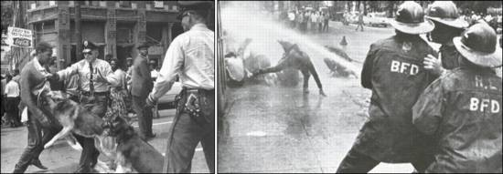

The need for civil and human rights 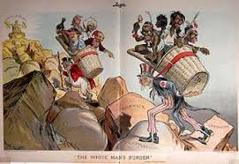

- A factor that led to racism and the domination of white people over other races in some countries comes from the idea of ______________________ which began during 1900 and imperialism.
- Explain in your own words:_________________________________________________________________________________________________________________________________________________________________________________________________________________________________
- In some areas such as the United States and South Africa, the need for cheap labor was filled by the native people or slaves that were brought into the country from somewhere else.
- Eventually when slavery was abolished or made illegal, there were still ideas that races could not mix. This led to many laws that tried to make people of color work for little money, took away their rights and made them live separate than the white people.

  - Some examples are:______________________________________________________.
When a group of people are separated by race it is known as _______________________.
Do you think segregation still happens today?_________________________________________________________________________________________________________________________________________________________________________________________________________________________________________________________________________________________________________________________________________________________________________________________________________________________
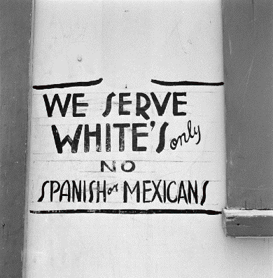
Picture Taken in Illinois, 2010
______________________is an Afrikaans word for segregation in South Africa which ended in 1994.
Is Apartheid similar to American segregation? Why or why not?_______________________________________________________________________________________________________________________________________________________________________________________________________________________________________________________________________________________________________________________________________
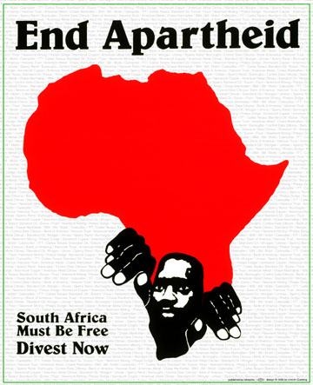

The people fought against:
Bigotry: _________________________________________________________________________________________________________________________________________________________________
Discrimination: _____________________________________________________________________________________________________________________________________________________________________
Racism: ______________________________________________________________________________________________________________________________________________________________________
They fought by:
Boycotts: ______________________________________________________________________________________________________________________________________________________________________
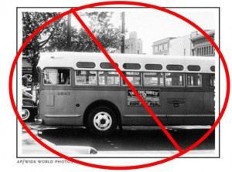 This is an example of the ___________________________________________.
Protests: _____________________________________________________________________________________________________________________________________________________________________
Tolerance: ______________________________________________________________________________________________________________________________________________________________________
Discussion: How would you fight injustice and fight for civil rights?
- Is there still a need for civil rights today?

Human rights and civil rights big events
The Civil Rights act of 1964: _________________________________________________________________________________________________________________________________________________________________________________________________________________________________________________________
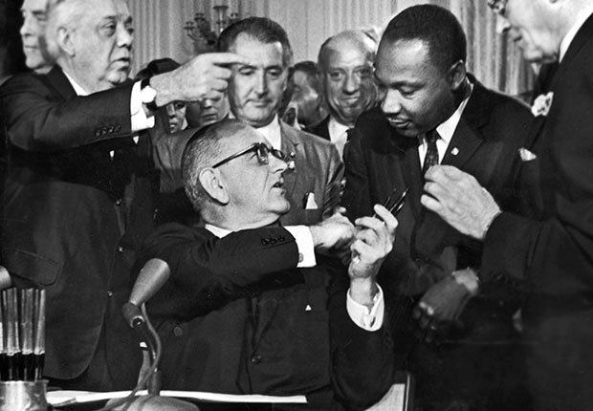

The African charter on human and people’s rights: ____________________________________________________________________________________________________________________________________________________________________________________________________________________________________________________________________________________________________________________________________________

Why is it important for human and civil rights to be available to everyone? Does that happen in the United States or are there things to work on?_____________________________________________________________________________________________________________________________________________________________________________________________________________________________________________________________________________________________________________________________________________________________________________________________________________________________________________________________________________________________________________________________________________________________________________________________________________________________________________________________________________________________________________________________________________________________________________________________________________________________________________________________________________________________________________________________________________________________________________________________________________________________________________________________________________________________________________________________________________________________________________________________________________________________________________________________________________________________________________________________________________________________________________

