Nelson Mandela
- Occupation: President of South Africa and Activist 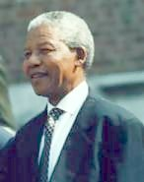
- Born: July 18, 1918 in Mvezo, South Africa
- Died: December 5, 2013 in Johannesburg, South Africa
- Best known for: Serving 27 years in prison as a protest against apartheid
Biography:
Nelson Mandela was a civil rights leader in South Africa. He fought against apartheid, a system where non-white citizens were segregated from whites and did not have equal rights. He served a good portion of his life in prison for his protests, but became a symbol for his people. Later he would become president of South Africa.
Background:
Nelson Mandela was born on July 18, 1918 in Mvezo, South Africa. His birth name is Rolihlahla. In school, Mandela learned about African history and his ancestors’ struggles with discrimination. He wanted to help his countrymen. He got the nickname Nelson from a teacher in school. Nelson was a member of Thimbu royalty and his father was chief of the city of Mvezo. He attended school and later college at the College of Fort Hare and the University of Witwatersrand. At Witwatersrand, Mandela got his law degree and would meet some of his fellow activists against apartheid. He later traveled to Johannesburg, where he studied law and opened the country’s first black law practice. He also joined the African National Congress; a group that fought for racial equality.
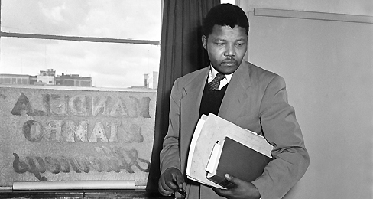
What did Nelson Mandela do?
Nelson Mandela became a leader in the African National Congress (ANC). At first he pushed hard for the congress and the protesters to follow Mohandas Gandhi's non-violence approach. At one point he started to doubt that this approach would work and started up an armed branch of the ANC. He planned to bomb certain buildings, but only the buildings. He wanted to make sure than no one would be hurt. In 1948, the government introduced apartheid, which left the country’s nonwhite majority with few economic opportunities. In response, Mandela traveled throughout South Africa and encouraged people to take part in nonviolent demonstrations against the government’s racial segregation policies. He was classified as a terrorist by the South African government and sent to prison. He was arrested for organizing anti-government activities and eventually sentenced to life in prison. “I have cherished the ideal of a democratic and free society in which all persons live together in harmony and with equal opportunities,” he said during his trial. “It is an ideal which I hope to live for and to achieve. But if needs be, it is an ideal for which I am prepared to die.”
Mandela would spend the next 27 years in prison. His prison sentence brought international visibility to the anti-apartheid movement. He was finally released through international pressure in 1990. 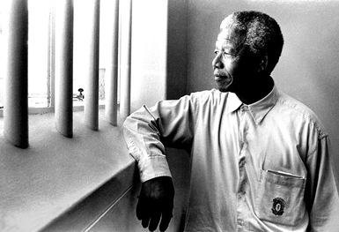
Once released from prison, Nelson continued his campaign to end apartheid. His hard work and life long effort paid off when all races were allowed to vote in the 1994 election. Nelson Mandela won the election and became president of South Africa. There were several times during the process where violence threatened to break out. Nelson was a strong force in keeping the calm and preventing a major civil war.
First Black President
On February 11, 1990, South African president F.W. de Klerk released Mandela from prison, and the two worked together to end apartheid. Three years later, they won the Nobel Peace Prize for their efforts.
In 1994, for the first time in South African history, nonwhites were allowed to vote in democratic elections. Mandela was elected president by an overwhelming majority. While in office, he worked to improve housing, education, and economic opportunities for the country’s large black population.
Mandela stepped down as president in 1999. That same year, he created the Nelson Mandela’s Children Fund, a charity that helps poor South African children. “Children are the wealth of our country,

Martin Luther King Jr.
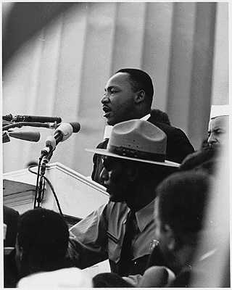
- Occupation: Civil Rights Leader
- Born: January 15, 1929 in Atlanta, GA
- Died: April 4, 1968 in Memphis, TN
- Best known for: His "I have a dream" speech
Biography:
Martin Luther King Jr. was a civil rights activist in the 1950s and 1960s. He led non-violent protests to fight for the rights of all people including African Americans. He hoped that America and the world could become a colorblind society where race would not impact a person's civil rights. He is considered one of the great orators of modern times and his speeches still inspire many to this day.
Background and influences
Martin Luther King Jr. was born in Atlanta, GA on January 15, 1929. He went to Booker T. Washington High School. He was so smart that he skipped two grades in high school and started his college education at Morehouse College at the young age of fifteen. Depression-era breadlines heightened King’s awareness of economic inequities, and his father’s leadership of campaigns against racial discrimination in voting and teachers’ salaries provided a model for the younger King’s own politically engaged ministry. He resisted religious emotionalism and as a teenager questioned some facets of Baptist doctrine, such as the bodily resurrection of Jesus.
During his undergraduate years at Atlanta’s Morehouse College from 1944 to 1948, King gradually overcame his initial reluctance to accept his inherited calling. Morehouse president Benjamin E. Mays influenced King’s spiritual development, encouraging him to view Christianity as a potential force for progressive social change. Religion professor George Kelsey exposed him to biblical criticism and, according to King’s autobiographical sketch, taught him “that behind the legends and myths of the Book were many profound truths which one could not escape” (Papers 1:43). King admired both educators as deeply religious yet also learned men and by the end of his junior year, such academic role models and the example of his father led King to enter the ministry.. After getting his degree in sociology from Morehouse, Martin got a divinity degree from Crozer Seminary and then got his doctor's degree in theology from Boston University.
How did he get involved in civil rights?
In his first major civil rights action, Martin Luther King Jr. led the Montgomery Bus Boycott. This started when Rosa Parks refused to move to give up her seat on a bus to a white man. As a result, Martin led a boycott of the public transportation system. The boycott lasted for over a year. It was very tense at times. Martin was arrested and his house was bombed, but in the end he prevailed and segregation on the Montgomery busses ended.
King’s rise to fame was not without personal consequences. In 1958 King was the victim of his first assassination attempt. Although his house had been bombed several times during the Montgomery bus boycott, it was while signing copies of Stride Toward Freedom that Izola Ware Curry stabbed him with a letter opener. Surgery to remove it was successful, but King had to recuperate for several months, giving up all protest activity
Success in Birmingham provided further impetus to the movement. This culminated in the massive March on Washington for Jobs and Freedom on 28 August 1963. More than 200,000 people were in attendance at the Lincoln Memorial when King delivered his famous ‘I have a dream’ speech, predicting a day when the promise of freedom and equality for all would become a reality in America. 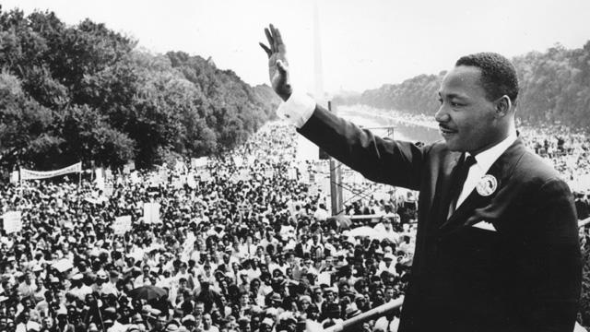
However, less than a month after King delivered his speech a blast killed four young girls in a Birmingham church. There was much work to be done if his dream was to be realized.
Fun Facts about Martin Luther King Jr.
- King was the youngest person to be awarded the Nobel Peace Prize in 1964.
- Martin Luther King Jr. Day is a national holiday.
- At the Atlanta premier of the movie Gone with the Wind, Martin sang with his church choir.
- There are over 730 streets in the United States named after Martin Luther King Jr.
- One of his main influences was Mohandas Gandhi who taught protesting in a non-violent manner.

