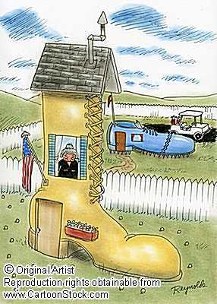
You are going to create a children’s book based upon 10 economic concepts learned throughout the unit. These terms should be used in a story that an elementary student could understand.
Requirements:
- The children’s story must have the following:
- Plot
- Dialogue
- Illustrations (printed or hand drawn)
- 10economic terms imbedded into the story
- Moral or message found somewhere within the pages

- The story needs to be 8 pages in length. It may be longer.
  - You must turn in a ROUGH DRAFT

- This project is to be done independently. No Groups
- Be Creative
- Looks Neat and well put together
- MUST BE TYPED (Can be creative font but no bigger than 16 font size)
- Economic terms must be UNDERLINED and used correctly within the story.
- Need to include a GLOSSERY on the last page defining the economic terms used.
- The story may also be bilingual as long as each page includes the translation.

- Your story must be done at a K-3th grade level – promote economic literacy of concepts.

- For CASS hours – create an extra activity that you could do with students to show understanding of terms

- The children’s story needs a cover page. (Must be stapled to your story)
Example: Title of Children’s Story
Your Name
Civics Period ___
Mr. Colondres
List the 12 key economic concepts: (example: economic incentives etc.)
____________________________________________________________________________________________________________
Grading Rubric: In order to receive an A you need to:
CRITERION A: KNOWLEDGE AND UNDERSTANDING
In your storybook you:
Discussed 10 of the key concepts accurately and appropriately in the context of the story demonstrate good knowledge and understanding of content and concepts through accurate descriptions, explanations and examples.
- terms are only used to advance the economic plot in a meaningful way
- terms are seamlessly interconnected throughout the story’s plot
CRITERION D: COMMUNICATION
In your storybook you:
Communicated information and ideas/morals by using a style that is often appropriate to children

