**Prediction:** is when you **guess** what is going to happen in the book based on things like the: **title, pictures, what happened in the previous sections and your past experience with similar books.**

**Summary:** using as few words as possible to give the most **important information** about the book.



**Connection:** you are **reminded** of something in **your life** while reading the book.

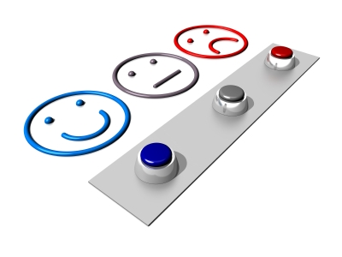

**Evaluation:** you make a **judgment** about the book and explain why you did or did not like what happened in the story.